

Lab # 06

Web Engineering Fall 2020



Instructor | Mr. Safder Ali
Student Name | Hamad Ali Shah
CMSID | 454591
Department | Bscs-23
Semester | 5TH semester

PRELAB WRITING ASSIGNMENT
Fill in the blanks | - Bootstrap is a popular CSS framework for building responsive and mobile-first websites.  - It provides a set of CSS and JavaScript components that can be easily customized and used in web development.  - The grid system in Bootstrap allows you to create responsive layouts by dividing the page into 12 equal-width columns.  - Bootstrap utilizes predefined classes to apply predefined styles and behaviors to HTML elements.  - Bootstrap is based on HTML and CSS programming languages and includes both CSS and JavaScript components.  .

Lab 6.2 | Lab Tasks

Description:
Your task is to create a responsive portfolio web page using Bootstrap. The web page should showcase your skills, projects, and contact information. It should be visually appealing and work well on different screen sizes.

Requirements:
- Use Bootstrap to create a responsive layout for your web page.
- Include a navigation bar with links to different sections of the page (e.g., Home, About, Projects, Contact).
- Create a section to showcase your skills. Use Bootstrap's grid system to display your skills in a visually appealing way.
- Design a section to showcase your projects. Use Bootstrap's card component to display project details, including project name, description, and an image.
- Add a contact form to collect user information. Use Bootstrap's form components to create the form fields (e.g., name, email, message).
- Make sure the web page is visually appealing by applying Bootstrap's predefined styles and components.
- Ensure that the web page is fully responsive and looks good on different devices and screen sizes.

Hints:
  - Use Bootstrap's documentation (https://getbootstrap.com/docs/) to explore available components, classes, and utilities.
  - Make use of Bootstrap's grid system to create a responsive layout.
  - Customize the styles by modifying Bootstrap's CSS classes or adding your own CSS rules.

Github link:

Desktop version:
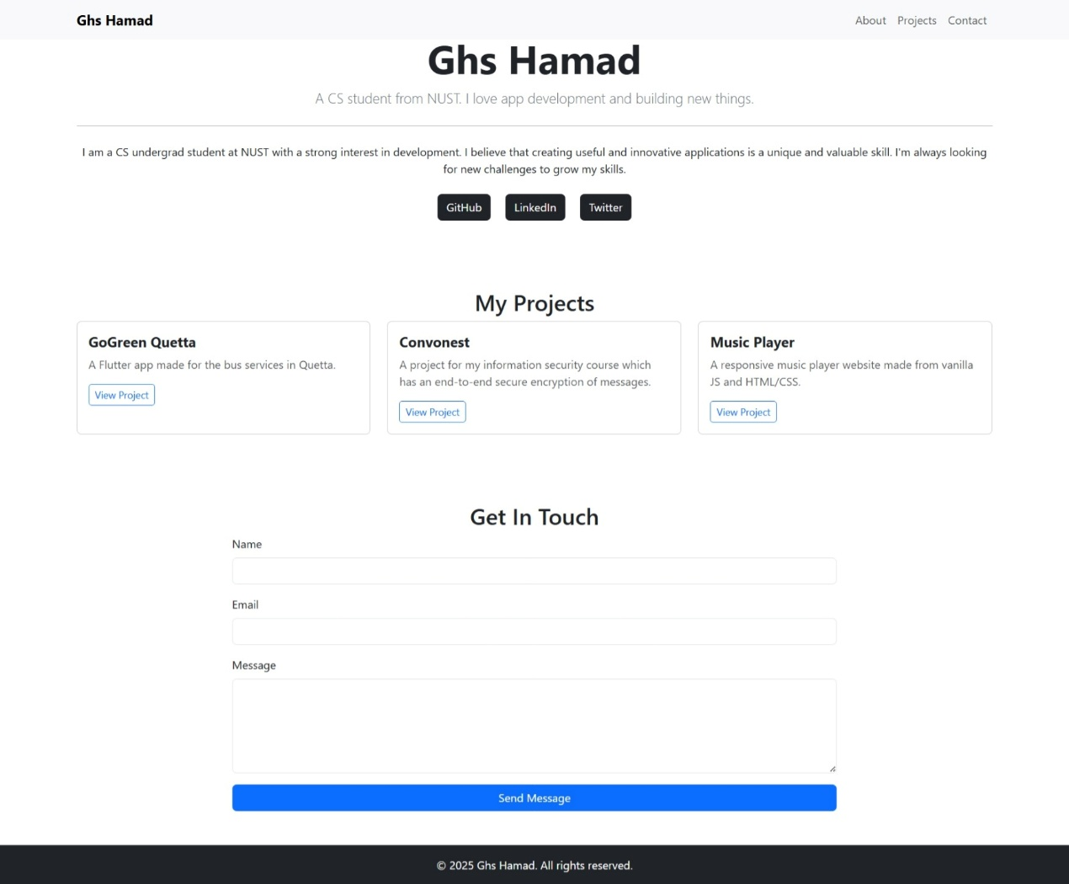

Mobile version:
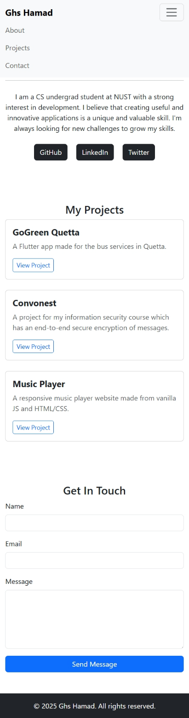
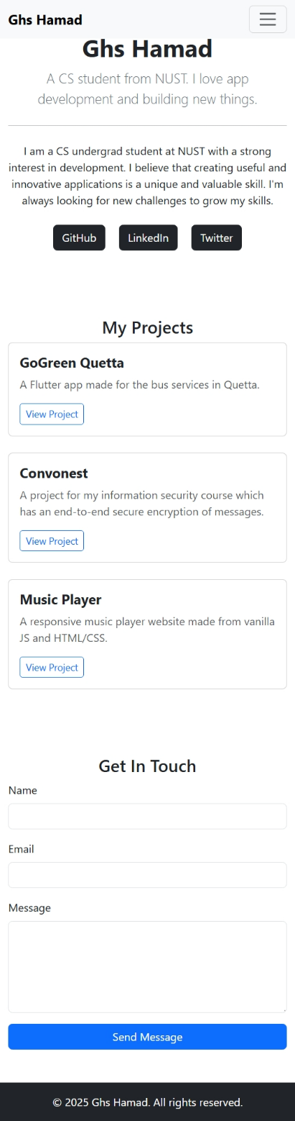

Additional Challenge (optional):
  - Implement a responsive image gallery using Bootstrap's carousel component to showcase your project screenshots or portfolio images.

